Policy and Action Standard: Sample reporting template

This sample reporting template includes all of the reporting requirements of the Greenhouse Gas Protocol Policy and Action Standard. This template illustrates one example of how the required information can be reported. Users of the standard may report the results in any format that is most useful to the intended audience, provided all the required information is reported.

Part 1: GHG assessment information

Reporting requirement | Response
The title of the policy or action (or package of policies/actions) assessed
(Reference: Section 5.2)
The objective(s) and intended audience of the GHG assessment
(Reference: Chapter 2)
The year the assessment was developed
Whether the reported assessment is an update of a previous assessment, and if so, links to any previous assessments
The GHG assessment period
(Reference: Section 7.3)
Whether the GHG assessment is an ex-ante assessment, an ex-post assessment, or a combined ex-ante and ex-post assessment
(Reference: Section 5.4)
Whether the assessment applies to an individual policy/action or a package of policies/actions, and if a package, which individual policies and actions are included in the package (Reference: Section 5.3)

Part 2: Description of the policy or action assessed
(Reference: Section 5.2)

Information | Response
The status of the policy or action (planned, adopted, or implemented)
The date of implementation
The date of completion (if applicable)
The implementing entity or entities
The objective(s) of the policy or action
The type of policy or action
A description of the specific interventions included in the policy or action
The geographic coverage
The primary sectors, sub-sectors, and emission source/sink categories targeted
The greenhouse gases targeted (if applicable)
Other related policies or actions
Key performance indicators (if applicable)
Intended level of mitigation to be achieved and/or target level of key indicators (if applicable)
Title of establishing legislation, regulations, or other founding documents (if applicable)
Monitoring, reporting, and verification procedures (if applicable)
Enforcement mechanisms (if applicable)
Reference to relevant guidance documents (if applicable)
The broader context/significance of the policy/action (if applicable)
Outline of non-GHG effects or co-benefits of the policy or action (if applicable)
Other relevant information (if applicable)

Part 3: Estimated change in GHG emissions and removals resulting from the policy or action
(Reference: Chapters 8, 9, 11)

Estimated change in GHG emissions and removals over the GHG assessment period (in metric tons of carbon dioxide equivalent)

Year | Total net change in emissions and removals | Uncertainty range (quantitative estimate or qualitative description)
Year 1
Year 2
Year 3
Year 4
Year …
Total cumulative emissions and removals

Year | Net change in emissions and  removals occurring… |  | Total net change in emissions and removals (A+B)
 | Within the implementing jurisdiction’s geopolitical boundary*  (A) | Outside of the implementing jurisdiction’s geopolitical boundary*  (B)
Year 1
Year 2
Year 3
Year 4
Year …
Total cumulative net change in emissions and removals

Year | Total net policy scenario emissions and removals**  (A) | Total net baseline scenario emissions and removals**  (B) | Total net change in emissions and removals (A-B)
Year 1
Year 2
Year 3
Year 4
Year …
Total cumulative emissions and removals
Notes: * In-jurisdiction effects and out-of-jurisdiction effects need not be reported separately, if not relevant or feasible. ** Total policy scenario emissions and total baseline scenario emissions need not be reported if not feasible.
Part 4: Methodology

Causal chain
(Reference: Chapter 6)
Example:
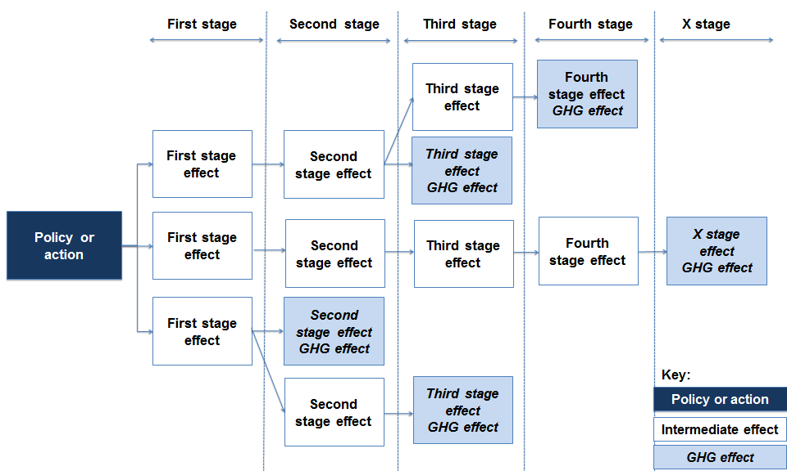

GHG assessment boundary
(Reference: Chapter 7)

Potential greenhouse gas effects of the policy or action | Source/sink categories affected | Greenhouse gases affected | Positive or negative emissions effect | Included or excluded in the assessment (effects, sources/ sinks, and gases) | Justification for exclusions (if applicable)

Reporting requirement | Response
The approach used to determine the significance of GHG effects

Baseline methodology
(Reference: Chapter 8)

Reporting requirement | Response
Description of the baseline scenario (i.e., a description of the events or conditions most likely to occur in the absence of the policy or action)
Justification for why it is considered the most likely scenario
The methodology and assumptions used to estimate baseline emissions, including the emissions estimation method(s) (including any models) used
Justification for the choice of whether to develop new baseline assumptions and data or to use published baseline assumptions and data
A list of policies, actions, and projects included in the baseline scenario
Any implemented or adopted policies, actions, or projects with a potentially significant effect on GHG emissions excluded from the baseline scenario, with justification for their exclusion
Whether the baseline scenario includes planned policies and if so, which planned policies are included
A list of non-policy drivers included in the baseline scenario
Any relevant non-policy drivers excluded from the baseline scenario, with justification for their exclusion
Any potential interactions with other policies and actions, and whether and how policy interactions were estimated
Any sources, sinks, or greenhouse gases in the GHG assessment boundary that have not been estimated in the baseline scenario, with justification, and a qualitative description of those sources, sinks, or gases
Whether the baseline scenario includes any planned policies and if so, which planned policies are included
Additional references or sources (if applicable)

Key parameters used to estimate baseline emissions (including activity data, emission factors, and GWP values)
(Reference: Chapter 8)

Parameter | Baseline value(s) applied over the GHG assessment period | Methodology and assumptions to estimate value(s) | Data source(s)
Parameter 1
Parameter 2
Parameter 3
Parameter…

Ex-ante methodology (if applicable)
(Reference: Chapter 9)

Reporting requirement | Response
Description of the policy scenario (i.e., a description of the events or conditions most likely to occur in the presence of the policy or action)
The methodology and assumptions used to estimate policy scenario emissions, including the emissions estimation method(s) (including any models) used
Any potential interactions with other policies and actions, and whether and how policy interactions were estimated
Any sources, sinks, greenhouse gases, or GHG effects in the GHG assessment boundary that have not been estimated in the policy scenario, with justification, and a qualitative description of the change to those sources, sinks, or gases
Additional references or sources (if applicable)

Key parameters used to estimate ex-ante policy scenario emissions (including activity data, emission factors, and GWP values) (if applicable)
(Reference: Chapter 9)

Parameter | Policy scenario value(s) applied over the GHG assessment period | Methodology and assumptions to estimate value(s) | Data source(s)
Parameter 1
Parameter 2
Parameter 3
Parameter…

Monitoring performance over time (if applicable)
(Reference: Chapter 10)

Key performance indicators/parameters | Rationale for their selection | Data source(s) | Monitoring methods/ frequency | The performance of the policy or action over time, as measured by key performance indicators
Indicator/parameter 1
Indicator/parameter 2
Indicator/parameter…

Reporting requirement | Response
Whether the performance of the policy or action is on track relative to expectations
Whether the assumptions on key parameters within the ex-ante assessment remain valid
Ex-post methodology (if applicable)
(Reference: Chapter 11)

Reporting requirement | Response
The methodology and assumptions used to estimate policy scenario emissions, including the emissions estimation method(s) (including any models) used
Any potential interactions with other policies and actions, and whether and how policy interactions were estimated
If data are normalized, the normalized results separately reported from the non-normalized results, and the normalization methods used
A description of differences between results from top-down and bottom-up methods (if applicable)
Any sources, sinks, or greenhouse gases in the GHG assessment boundary that have not been estimated in the policy scenario, with justification, and a qualitative description of the change to those sources, sinks, or gases
Additional references or sources (if applicable)

Key parameters used to estimate ex-post policy scenario emissions (including activity data, emission factors, and GWP values) (if applicable)
(Reference: Chapter 11)

Parameter | Policy scenario value(s) applied over the GHG assessment period | Methodology and assumptions to estimate value(s) | Data source(s)
Parameter 1
Parameter 2
Parameter 3
Parameter…

Uncertainty
(Reference: Chapter 12)

Reporting requirement | Response
The range of results from sensitivity analysis for key parameters and assumptions
The method or approach used to assess uncertainty
Additional references or sources (if applicable)

Verification
(Reference: Chapter 13)

Reporting requirement | Response
Whether the GHG assessment results were verified
Type of verification (first party or third party), if applicable
Relevant competencies of the verifier(s), if applicable
The opinion issued by the verifier, if applicable

Part 4: Optional reporting information

Users should report the following information where relevant.

Optional information | Response
Probability-adjusted estimate (or expected value) of the net changes in GHG emissions and removals resulting from the policy or action
A range of likely values for the net change in GHG emissions and removals, rather than a single estimate (for example, based on alternative baseline scenarios, uncertainty assessment, or sensitivity analysis)
Net changes in GHG emissions and removals separately reported by individual effect, type of effects, or sources/sinks category
Net changes in GHG emissions and removals resulting from likely effects, separately reported from net changes in GHG emissions and removals resulting from unlikely effects
Net changes in GHG emissions and removals, separately reported by likelihood category (very likely, likely, possible, unlikely, very unlikely)
Annual or cumulative GHG effects over time periods other than the GHG assessment period
The GHG inventory of the organization or jurisdiction implementing the policy or action
Historical GHG emissions of the jurisdiction or organization implementing the policy or action
GHG mitigation goal(s) of the jurisdiction or organization implementing the policy or action
The contribution of the assessed policy or action toward the organization or jurisdiction’s GHG mitigation goal
Any potential overlaps with other policies and actions
Any possible double counting of GHG reductions by other parties that may claim GHG reductions from the same policies or actions, and any practices or precautions used to avoid double counting
Estimated non-GHG effects (i.e., co-benefits) of the policy or action and the methodologies used to quantify non-GHG effects
Cost and/or cost-effectiveness of the policy or action and the methodologies used to quantify costs
Other relevant information

