

You were contracted by Ice Cold Beverages (an imaginary company) to complete its first GHG emissions inventory, for calendar year 2009. Information about the company’s structure and data about its activities are provided below. Use the template provided on the last page of this exercise to complete Ice Cold’s GHG inventory.

Ice Cold’s management has asked that you use the operational control consolidation approach in determining organizational boundaries. Also, because a fixed amount of time has been allotted to completion of this exercise, please only account for Scopes 1 and 2.

Desciption: Ice Cold Beverages
Ice Cold is a small beverage company that started operations in 1999. Today, Ice Cold has a 10% beverage market share in its region, and it consists of a central office, two beverage production plants, a distribution center and a delivery vehicle fleet.

Structure of Ice Cold Beverages

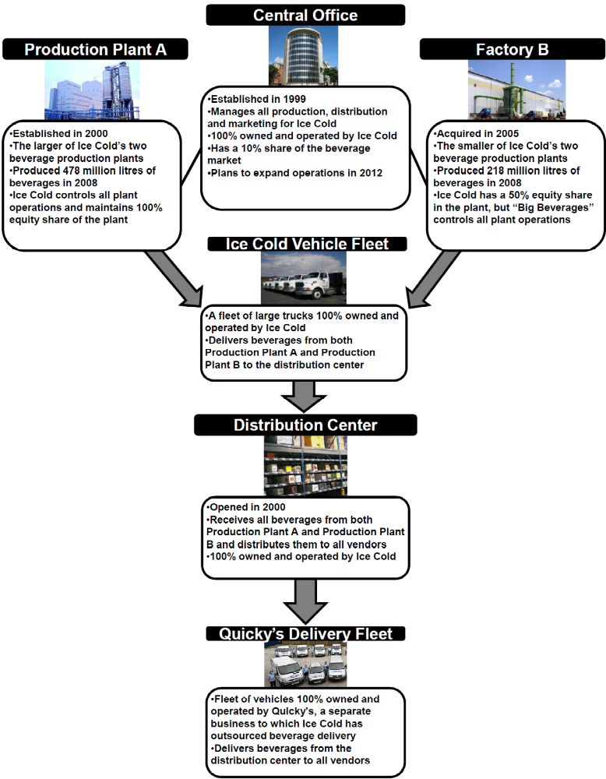
Data for Ice Cold’s facilities

Central Office
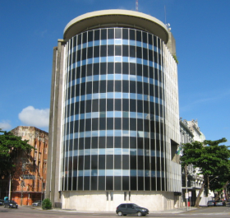

Ice Cold’s central office is located in New York City. The central office is in a commercial building and occupies 1,000 m² of the second floor, which is a total of 4,000 m². The electricity consumed monthly by the entire second floor is shown in the table below:

Table 1: Monthly electricity consumption of second floor
Month | Jan | Feb | Mar | Apr | May | Jun | Jul | Aug | Sept | Oct | Nov | Dec
kWh | 1610 | 1755 | 1770 | 1565 | 1735 | 1645 | 1655 | 1605 | 1640 | 1595 | 1655 | 1510

In addition, Ice Cold’s central office purchases renewable energy certificates (RECs) through a green label offered by the local electric utility. These purchases are made by the building owner to cover 100% of all electricity consumed in the building. These RECs meet the Scope 2 Quality Criteria.

Ice Cold’s central office is also equipped with central air conditioning. The air conditioning equipment uses the refrigerant R-410A, of which there was 30 kg in storage at the beginning of 2009 (the reporting year), and 10 kg in storage at the end of the year. Over the reporting period, no refrigerant or air-conditioning equipment was purchased and no refrigerant was transferred offsite (e.g., sold to other companies or destroyed).

The sales team based in Ice Cold’s central office uses company-owned vehicles for sales trips. The company-owned vehicles were purchased in 2007 and are only used for business travel. Ice Cold recorded each car’s odometer at the beginning and end of the year to find that during the entire year, all company owned cars traveled a total of 450,000 miles. The vehicles are gasoline (petrol)-powered passenger cars.

Production Plant A
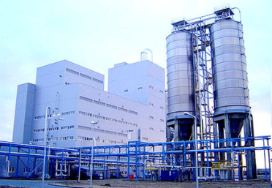

Ice Cold’s Production Plant A, located in Mexico, gets all of its electricity from a local electric utility who discloses a CO₂ emission factor of 0.252 kg CO₂/kWh (emission factors for CH₄ and N₂O are unavailable). That supplier-specific emission rate meets the Scope 2 Quality Criteria.

Production Plant A’s complete monthly electricity usage is shown in the table below. Because it has access to product or supplier-specific information, Ice Cold will report two scope 2 numbers: one location-based, and one-market-based.

Table 2: Total monthly electricity consumption for Production Plant A
Month | Jan | Feb | Mar | Apr | May | Jun | Jul | Aug | Sept | Oct | Nov | Dec
kWh | 26770 | 26110 | 25040 | 22565 | 23355 | 22325 | 20615 | 21660 | 25935 | 27740 | 29395 | 29935

The production processes at Production Plant A are powered by energy generated on-site from combustion of both diesel oil and natural gas. In 2009, Production Plant A combusted 7,500 litres of diesel oil and 1,000 m³ of natural gas.

Factory B
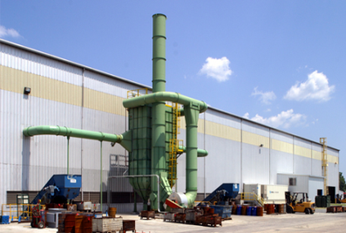
Ice Cold’s Factory B, also located in Mexico, formed a power purchase agreement with a wind farm development. The contract specifies the delivery of 0 t CO2/ kWh, and meets the Scope 2 Quality Criteria (emission factors for CH₄ and N₂O are unavailable). Factory B’s complete monthly electricity usage is shown in the table below.

Table 3: Total monthly electricity consumption for Factory B
Month | Jan | Feb | Mar | Apr | May | Jun | Jul | Aug | Sept | Oct | Nov | Dec
kWh | 19274 | 18799 | 18029 | 16247 | 16816 | 16074 | 14843 | 15595 | 18673 | 19973 | 21664 | 21553

A boiler in Factory B combusts liquified petroleum gas (LPG) to power production processes. Ice Cold’s financial records indicate that 84,600 kg of LPG were purchased and used throughout the year.

Factory B also utilizes a refrigerating unit, which uses HFC-134a, for cooling purposes during the production process. At the beginning of the year, Ice Cold had 1000 kg of HFC-134a in storage, and by the end of the year, it only had 200 kg of HFC-134a remaining in storage.

Ice Cold Vehicle Fleet
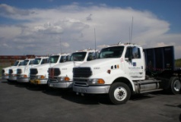

Ice Cold has its own fleet of trucks to transport beverages between Production Plant A, Factory B and its distribution center. Over the course of the entire year, Ice Cold purchased and consumed 968,500 gallons of diesel for use in its fleet of heavy duty (rigid) trucks. (The truck fleet is based in the United States.)

Distribution Center
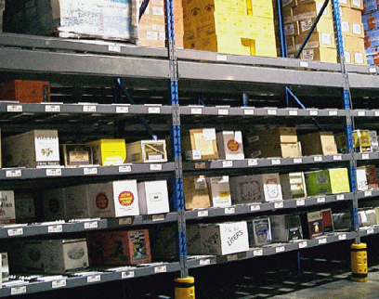

The Ice Cold Distribution Center is located in Texas and gets all of its electricity from the ERCOT regional grid. It also purchases renewable energy certificates (RECs) to match 50% of its consumption. These RECs meet the Scope 2 Quality Criteria. There is no residual mix available in the U.S. currently for the market-based method calculation.

Because it has access to product or supplier-specific information, Ice Cold will report two scope 2 numbers: one location-based, and one-market-based. Ice Cold used its monthly energy bills to determine its entire monthly electricity consumption, shown in the table below:

Table 4: Total monthly electricity consumption for the Ice Cold Distribution Center
Month | Jan | Feb | Mar | Apr | May | Jun | Jul | Aug | Sept | Oct | Nov | Dec
kWh | 3855 | 3760 | 3606 | 3249 | 3363 | 3215 | 2969 | 3119 | 3735 | 3995 | 4233 | 4311

Quicky’s Delivery Fleet


Quicky’s Delivery Fleet is an independently owned and operated company to which Ice Cold has outsourced the transportation of beverages from the Ice Cold Distribution Center to all retail outlets. Each year Quicky’s provides Ice Cold with a record of total miles traveled for the delivery of Ice Cold beverages. In 2009, Quicky’s vehicles traveled 760,800,000 miles within the United States via its fleet of heavy duty (rigid) diesel trucks while providing delivery services to Ice Cold.

GHG Inventory: Ice Cold Beverages

Organizational Boundaries
Consolidation Approach Chosen

Facilities included in GHG inventory

Operational Boundaries
Operational Boundaries (Scopes included)
Reporting Period

Tracking Emissions Over Time
Base year and emissions profile over time

Emissions Calculations
Total Scope 1 and 2 emissions (using market-based method)
Total Scope 1 and 2 emissions (using location-based method)
Total Scope 1 emissions
Total Scope 2 emissions (market-based)
Total Scope 2 emissions (location-based)

